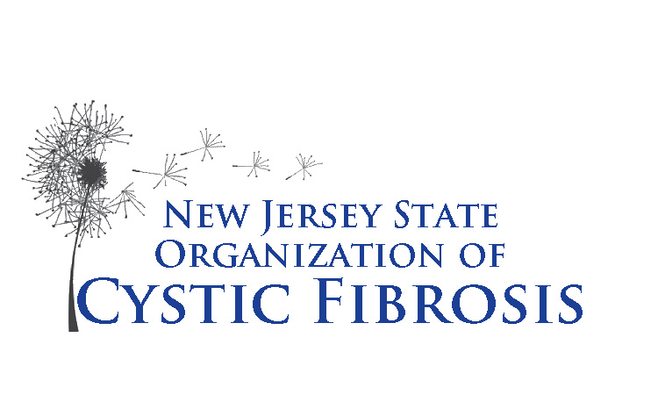

New Jersey State Organization
of Cystic Fibrosis

137 Union Boulevard
Totowa, NJ 07512
973-595-1232 ● Fax 973-595-1718
Email: das@njsocf.org

Pharmaceutical Services for Adults with Cystic Fibrosis

Application Form

PROGRAM REQUIREMENTS

- Diagnosis of Cystic Fibrosis verified by CF doctor
- Must be a New Jersey resident
- Must be 18 years or older
- Individual annual income less than $57,706/year

COMPLETE THE APPLICATION AND MAIL WITH ALL REQUIRED DOCUMENTATION TO

New Jersey State Organization
of Cystic Fibrosis
P.O. Box 3648

Wayne, NJ 07474-3648

DOCUMENTS NEEDED TO PROCESS YOUR APPLICATION

Completed “Application” (original)
(Attach a copy of your New Jersey driver’s license or other proof of residency)

Completed, signed and notarized “Insurance Affidavit”
(Attach copies of all current health insurance cards)

Signed and notarized “Income and Acceptance Affidavit”
(Attach a copy of your Federal Income Tax Return with all W2’s,1099’S and/or your SSI Benefits Statement)

- Signed “Patient Authorization for Health Information Disclosure” (HIPPA compliant)

Failure to submit ALL of the above items will delay your acceptance
to the Program.

New Jersey State Organization
of Cystic Fibrosis

137 Union Boulevard
Totowa, NJ 07512
973-595-1232 ● Fax 973-595-1718
Email: das@njsocf.org

GRANT APPLICATION – Pharmaceutical Services for Adults with Cystic Fibrosis

Applicant Information

Full Name: Date:
Last First M.I.

Address:
Street Apartment/Unit #

City State ZIP Code

Home Phone: Cell Phone: Email:

Social Security No: Sex: Race:

Date of Birth: Place of Birth: Age diagnosed:

Marital Status: Married Single Divorced No. of Children

Parents/Guardians

Name:
Mother / Guardian

Address: Phone #:

Name:
Father/Guardian

Address: Phone #:

Employment/Social Security

Employed Student Social Security Other

Employer Information

Name of Employer: Phone #:

Address:

Full or Part Time: Occupation:

Student Information

Name of School: Full/Part Time:

Address:

Income/Assistance

Individual Annual Income from all sources:

(Attach a copy of recent Federal Income Tax Return, with all W-2’s, 1099’s, and/or Social Security Statement.)

Are you enrolled in any other Pharmaceutical Assistance Programs?

Are you receiving a grant from the Healthwell Foundation?

Physician/CF Centers

Name of CF Physician:

Name of CF Center:

Address:

Phone #:

List your current prescription medications and nutritional supplements:

In case of emergency please contact:

Phone #: Relationship:

I certify that the information given on this application is true and correct.

Date

Signature of Applicant

New Jersey State Organization
of Cystic Fibrosis

137 Union Boulevard
Totowa, NJ 07512
973-595-1232 ● Fax 973-595-1718
Email: das@njsocf.org

Pharmaceutical Services for Adults with Cystic Fibrosis

Income and Acceptance Affidavit

According to the terms of “Pharmaceutical Services for Adults with Cystic Fibrosis,” the definition of income is “wages, dividends, interest and any other income received from all sources. Spousal or family income must not be considered. However, half of interest and/or dividends from any investments held jointly will be considered income.”

Based on this definition of income, I attest that my individual total income does not exceed $57,706.

I understand that if I have provided erroneous information, I agree to pay back all benefits I have received to the New Jersey State Organization of Cystic Fibrosis (NJSOCF).

Furthermore, I understand that if I have supplied false information, I shall be disqualified.

The continuation of benefits and the payment of monthly allowances are at the discretion of NJSOCF. NJSOCF reserves the right to reduce or change any amounts paid on my behalf.

The New Jersey State Organization of Cystic Fibrosis shall not be held liable for any breach of the agreement because of the absence of available funding.

Under the terms of this agreement, I understand I must submit my Federal Income Tax Return with all my W-2’s, and my spouse’s, if applicable. If I did not file a tax return, I must submit my SSI/SSA Benefits Statement, or any other proof of income received in the year.

Date
Signature of Applicant

Please Print Name

Sworn to and subscribed before me
this day of , .

A Notary Public of New Jersey

New Jersey State Organization
of Cystic Fibrosis

137 Union Boulevard
Totowa, NJ 07512
973-595-1232 ● Fax 973-595-1718
Email: das@njsocf.org

Pharmaceutical Services for Adults with Cystic Fibrosis

Insurance Affidavit

INCLUDE COPIES OF ALL INSURANCE CARDS

Health Insurance

I am covered for Health Insurance: Private Medicare Medicaid
Plan Name: Policy or ID #:
Phone #: Effective Date: Annual Deductible: My Co-Payment(s) is:

Secondary Coverage, if any:
Plan Name: Policy or ID #:
Phone #: Effective Date: Annual Deductible: My Co-Payment(s) is:

Prescription Coverage

Plan Name: Policy or ID #:
Phone #: Effective Date: Annual Deductible: My Co-Payment(s) is:

( ) I DO NOT HAVE medical insurance coverage ( ) I DO NOT HAVE prescription coverage

I understand that if my medical and/or prescription insurance coverage should change in any way, I must notify the New Jersey State Organization of Cystic Fibrosis immediately. Furthermore, I understand that if I have provided false information, I agree to pay back all benefits I have received from “Pharmaceutical Services for Adults with Cystic Fibrosis” to NJSOCF.

Date
Signature of Applicant

Please Print Name
Sworn to and subscribed before me this
day of , .

A Notary Public of the State of New Jersey

New Jersey State Organization
of Cystic Fibrosis

137 Union Boulevard
Totowa, NJ 07512
973-595-1232 ● Fax 973-595-1718
Email: das@njsocf.org

Pharmaceutical Services for Adults with Cystic Fibrosis

Patient Authorization for Health Information Disclosure
(HIPPA compliant)

I, __________________________________, hereby authorize the New Jersey State Organization of Cystic Fibrosis, its agents, employees, and associates, to release and obtain my protected health information (PHI). This medical authorization hereby authorizes physicians, hospitals, and any medical attendant or records custodian to furnish full and complete medical records, applications and information to the New Jersey State Organization of Cystic Fibrosis, 137 Union Boulevard, Totowa, New Jersey 07512, (973-595-1232) or to any representative from said organization. Should you have questions with this request, please call us and reference our client’s name.

I understand that information used or disclosed pursuant to this authorization may be subject to re-disclosure by the authorized receipt and may no longer be protected by state and federal law.

I agree that a photographic copy of the authorization shall be as valid as the original. I understand that I may request a copy of this authorization. I understand that I may revoke this authorization at any time in writing unless action has been taken in reliance on my authorization. Should I choose to sign this authorization, I understand that I have the right to request access to my protected health information that may be used or disclosed to individuals that are not subject to HIPPA regulation.

This authorization for the protected health information also includes examination reports, hospital records, x-ray/CT-scan films, questionnaires, applications, and the furnishing of any other information including opinions.

I have authorized the New Jersey State Organization of Cystic Fibrosis to receive information in connection with Pharmaceutical Services for Adults with Cystic Fibrosis.

Your full cooperation with the New Jersey State Organization of Cystic Fibrosis is hereby requested.

Date
Signature of Applicant

Please Print Name

